PICNIC FAQ’S
All your questions answered about your picnic booking, but essential for you to know to ensure you have the best possible experience. Refer to our Terms & Conditions for detailed information.
Q. What are your picnic inclusions?
All of our picnic packages include set-up, styling and pack down, rubbish collection & disposal, rustic trestle picnic tables, assorted rugs, pillows & cushions, styled table decorations & décor, woven placemats, glassware, water carafes and an ice bucket with ice. All sunset and evening picnics include flameless tealights, candles & lanterns.
Visit our Instagram @malenypicnicsandproposals for images and ideas. We also recommend checking out the Maleny Picnics & Proposal website gallery to see which look is perfect for your event.
Q. Is Food & Drink included?
Maleny Picnics & Proposals include catering for all our Proposal Packages. Our picnics for 2, children’s, group and special picnics give you the option of adding catering or you can elect to BYO food and beverages. You are welcome to bring your own wine & food as we provide everything else you will require to enjoy an amazing picnic.
Should you wish us to arrange catering for your picnic, we collaborate with some awesome local caterers. They will accommodate any dietary requirement.
Q. How long is my booking for?
Our picnic packages range in sitting times from 90 minutes and up to 3 hours dependant on the size and type of package booked. However, you can book for additional time at $50 per hour, with a minimum of three (3) days notice, as we may have to extend the location booking.
Q. When do you set up a picnic?
Set up time all depends on the size of the event. Our small picnics normally require 1 hour to set up, however, our large luxe picnics can take up to 2 hours to set up.
Q. When do you pack down a picnic?
Once we have set-up your picnic, we leave you to enjoy your event with your guests.
For any picnics set up in Council Parks, we return at the end of your picnic event and pack up, all you have to do is get up and leave. If you have booked a picnic to take place in a private residence, we can collect the following day, subject to other bookings.
Unless otherwise arranged, our picnic set ups are collected on the day at a time previously agreed.
Q. What happens if I am running late?
We are pretty flexible and know life sometimes gets away from us, so we will hold your booking for 15 mins from the commencement time. If we have another picnic booked straight after your allocated time, we will be packing down at the designated time, otherwise, this can impact on our next picnic booking. If there is not another booking scheduled after your event, extra time can be negotiated for an extra fee.

Q. Do you customise quotes?
Yes we can! We can tailor a package to suit your particular requirements.
Q. Where is the best location to set up a picnic?
For both you and your guests comfort we recommend that our picnics be set up outside under the shade of a tree or, we can set up a picnic umbrella or cabana for you. For picnics booked on really hot & humid days your guests may prefer your picnic be set up inside in air-conditioning. We are pretty flexible as our picnics can be set-up anywhere, whether it’s in a park, in the backyard, on a verandah, balcony, deck, lounge, rumpus room, garage or shed.
Q. Do you also travel to locations on the Sunshine Coast?
Our picnic packages are available for hire in the greater Sunshine Coast Region. All picnic events located in the Sunshine Coast Hinterland area within a 25 km radius of Maleny include free travel. However, locations outside this may incur a travel fee and/or venue fee as below.
Travel costs:
- Set down & pack up for bookings greater than 25kms from Maleny Town Centre via the most direct route will incur an additional $50 (inc gst) surcharge.
- Set down & pack up for bookings greater than 50kms from the Maleny Town Centre via the most direct route will incur an additional $100 (inc gst) surcharge.
- Surcharge for set down & pack up bookings further than 100kms from the Maleny Town Centre via the most direct route will be negotiated with the Customer and Company.
Q. What Payments Do You Accept?
You can pay via Direct Deposit prior to your picnic.
Q. What happens if anything is damaged?
It is a condition of hire that any breakages or damage are the responsibility of the hirer and must be paid for by way of separate invoice.
If any rugs or cushions are stained with food or alcohol extra fees will be charged to cover the cleaning cost. Any breakages or items missing must be covered at full retail cost.
Small spillages (such as water or non-staining items) may not incur a fee. However, you may be billed for dry cleaning costs if required. Please inform your host at the end of your picnic if there has been any major spills or accidents so they can try to fix and avoid the dry cleaners OR replacing the item.
Q. Do you need a security bond?
No, as our picnics are small we do not require a security bond. However, in the event of any breakages or damages, a separate invoice will be sent to the hirer to rectify.
Q. What if I have to Cancel?
Due to the number of bookings, payments are non-refundable as we have held your date and turned down other events. We are happy to reschedule to another day (date subject to our availability).
Q. What’s your maximum number of guests?
With our picnic packages, we can cater from 2 and up to 24 people at any one time. However, we do offer combination picnic table and high dining table packages for up to 40 people.
If you are wishing to include a picnic for a wedding, engagement, elopement or large birthday celebration, we collaborate with our sister company Willow Wood Hire, Maleny who provide hire packages for up to 80 guests.

Q. Can I have my booking anywhere?
When we take on your booking, there's a tonne of stuff we need to consider, including safety, scheduling of bookings around yours, rostering of staff and a heap of other stuff that's probably really boring to you, but really important to us to ensure we are operating at our best. Bearing in mind that set ups include the lifting of heavy tables, rugs & tubs, the safety of our staff is of utmost importance to us, so here's the lowdown in a snapshot.
- The price in your quote are for easy access. If the setup requires extra walking and carrying heavy items to create your picnic there will be extra fees.
- Beach setups are absolutely beautiful however, sometimes access is harder and extra cleaning cost are required to remove sand. Extra fees will be added to your quote.
- If you'd like a specific spot in a Sunshine Coast Council park or beach area booked, it's up to you to organise this with the Sunshine Coast Council, as all permits must be issued to the customer.
Q. My numbers changed, now what?
Unfortunately, we can't reduce your package size once you've paid your deposit. Why? because we're often fully booked and turning bookings away. If you need to increase your package, we will do our best to accommodate subject to equipment availability.
Q. How do I book?
To book and lock in your preferred date, we just require a 25% deposit with the balance due seven (7) days prior to the event date. If your event is within seven (7) days of the event date, payment in full is required. Please note that deposits are non-refundable if you choose not to proceed with your event. If your booking is within 7 days of the cancellation date, full payment of the original quoted price is payable. Bookings on public holidays incur a surcharge of 15%, to cover the penalty rates we as a company are required to pay to service your booking.
Q. What if it's due to rain on the day of my booking?
All outdoor events are subject to the elements, so wet weather is completely out of our control. Should the weather not be perfect for your picnic event, we recommend you have a wet weather backup plan, so your picnic can still be fantastic. We are pretty flexible as our picnics can be set-up in any undercover area such as a verandah, balcony, deck, patio, lounge, rumpus room, garage or shed. We can set up in your private residence, B&B or other local tourist accommodation.
We also have a couple of amazing local weather backup locations (location fee may apply) which both offer protection from the rain while still offering stunning natural beauty.
Either party can change the date or location of the booking with four (4) days notice. If you do choose to change the location, you are responsible for finding the new location yourself.
We cannot refund payment due to wet weather cancellation. Your wet weather plan must be easy access or extra fees will apply.
Q. Can I drink at my booking?
In Qld, the consumption of alcohol in a public place is illegal and you do so at your own risk. Most councils will issue you with a permit to combat this, so best get in touch with the council of the location you choose just to cover your butt.
We do offer a number of Maleny Hinterland private venue locations where this is not an issue.
Q. Can we keep the floral arrangements?
Maleny Picnics & Proposals include fully styled picnic setups, with our dried florals and faux foliage table arrangements on a hire only basis. The table flower arrangements are not to be taken as they are a part of the setting decoration.
Should you wish to arrange your own fresh florals for your picnic, we can recommend some awesome local florists. Contact them directly to make arrangements however, please advise us of any florist details so we can co-ordinate directly with them on your event day.
Q. Can I choose my colours?
Yes you can! We want this to be perfect for you and what you love. We recommend checking out the Maleny Picnics & Proposal website gallery and Instagram to see which look is perfect for your event.
Q. Can we still have a group picnic during social distancing?
We are a COVID safe business and have policy and practice in place to ensure our guests enjoy their picnics in a safe way.
As most of our picnics are outdoors, there is no requirement to provide your vax status, which makes a picnic the perfect way to gather friends & family for a fun celebration outdoors, no matter what your personal preferences may be.
As regulations change, we will keep our clients informed of any changes that may affect their picnic bookings. However, since the pandemic started we have mostly been unaffected by these changes.
Share the Love
We encourage you to take photos of your beautiful Maleny Picnics & Proposals picnic experience and share the picnic love on your socials, tagging us @malenypicnicsandproposals. If you love what we do, our small local business we would also appreciate your Google 5 Star Review!

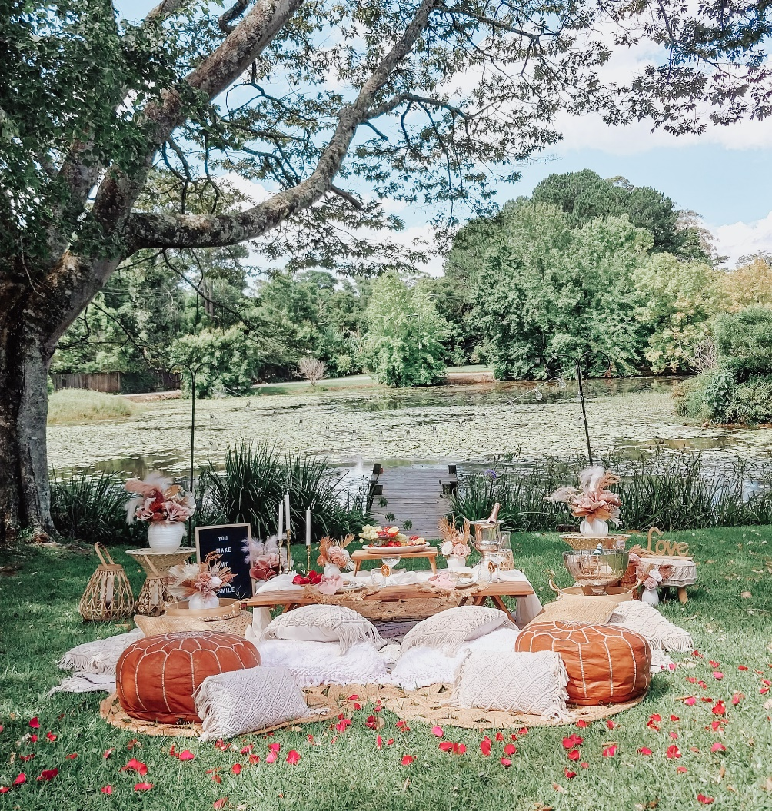
~Create Your Own Picnic Magic~

